Migration

🌟 Definition
# Source: AI Source: Provided by: [Data Path: Persons Table -> ID Column: 1, Name_En Column: Motasem Essam] -> From: [ChatGPT] on [6/7/2026]
Migration in software is the process of moving, upgrading, transforming, or transferring software components from one state, platform, system, technology, or environment to another.
The goal is to improve, modernize, scale, or replace existing systems while preserving functionality and data.

🎯 Simple Definition
# Source: AI Source: Provided by: [Data Path: Persons Table -> ID Column: 1, Name_En Column: Motasem Essam] -> From: [ChatGPT] on [6/7/2026]
Migration = Moving from Old State → New State
Examples:
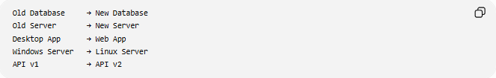
Old Database → New Database
Old Server → New Server
Desktop App → Web App
Windows Server → Linux Server
API v1 → API v2

🧠 Why Migrations Are Needed
# Source: AI Source: Provided by: [Data Path: Persons Table -> ID Column: 1, Name_En Column: Motasem Essam] -> From: [ChatGPT] on [6/7/2026]
Organizations perform migrations to:
- Upgrade technology
- Improve performance
- Reduce costs
- Increase security
- Move to the cloud
- Replace legacy systems
- Add new features
- Improve scalability

🔄 General Migration Process
# Source: AI Source: Provided by: [Data Path: Persons Table -> ID Column: 1, Name_En Column: Motasem Essam] -> From: [ChatGPT] on [6/7/2026]
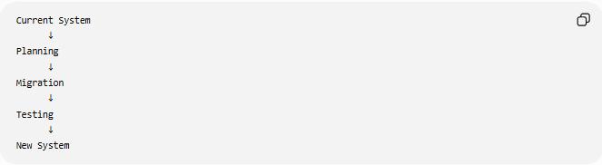
Current System
↓
Planning
↓
Migration
↓
Testing
↓
New System

📚 Common Types of Software Migration

1️⃣ Database Migration
# Source: AI Source: Provided by: [Data Path: Persons Table -> ID Column: 1, Name_En Column: Motasem Essam] -> From: [ChatGPT] on [6/7/2026]
Move or modify databases.
Example:
MySQL → PostgreSQL
Or
Add new columns and tables

2️⃣ Application Migration
# Source: AI Source: Provided by: [Data Path: Persons Table -> ID Column: 1, Name_En Column: Motasem Essam] -> From: [ChatGPT] on [6/7/2026]
Move applications to new environments.
Example:
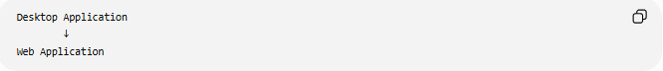
Desktop Application
↓
Web Application

3️⃣ Server Migration
# Source: AI Source: Provided by: [Data Path: Persons Table -> ID Column: 1, Name_En Column: Motasem Essam] -> From: [ChatGPT] on [6/7/2026]
Move software from one server to another.
Example:
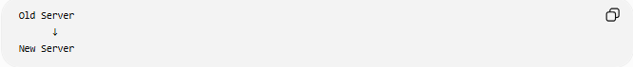
Old Server
↓
New Server

4️⃣ API Migration
# Source: AI Source: Provided by: [Data Path: Persons Table -> ID Column: 1, Name_En Column: Motasem Essam] -> From: [ChatGPT] on [6/7/2026]
Upgrade or replace APIs.
Example:
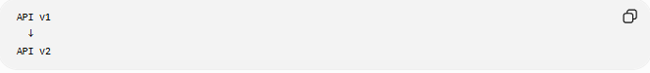
API v1
↓
API v2

📊 Real-World Examples
# Source: AI Source: Provided by: [Data Path: Persons Table -> ID Column: 1, Name_En Column: Motasem Essam] -> From: [ChatGPT] on [6/7/2026]
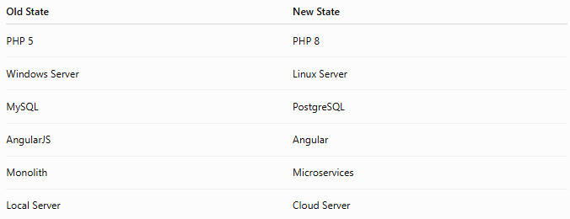
Old State | New State
PHP 5 | PHP 8
Windows Server | Linux Server
MySQL | PostgreSQL
AngularJS | Angular
Monolith | Microservices
Local Server | Cloud Server

🛠️ Example: Database Migration
# Source: AI Source: Provided by: [Data Path: Persons Table -> ID Column: 1, Name_En Column: Motasem Essam] -> From: [ChatGPT] on [6/7/2026]
Before
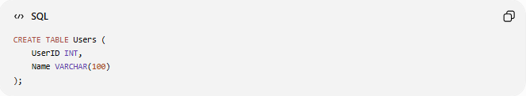
CREATE TABLE Users (
UserID INT,
Name VARCHAR(100)
);

Requirement
Add email support.

Migration
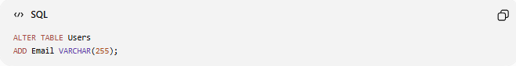
ALTER TABLE Users
ADD Email VARCHAR(255);

After
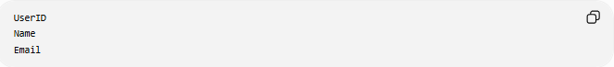
UserID
Name
Email
The database has been migrated to a newer version.

⚠️ Challenges of Migration
# Source: AI Source: Provided by: [Data Path: Persons Table -> ID Column: 1, Name_En Column: Motasem Essam] -> From: [ChatGPT] on [6/7/2026]
Migrations can be difficult because of:
- Data loss risks
- Downtime
- Compatibility issues
- Performance problems
- Security concerns

✅ Benefits of Migration
- Better performance
- Modern technology
- Easier maintenance
- Increased security
- Improved scalability
- Lower operational costs

🧠 Simple Analogy
# Source: AI Source: Provided by: [Data Path: Persons Table -> ID Column: 1, Name_En Column: Motasem Essam] -> From: [ChatGPT] on [6/7/2026]
Imagine moving from an old house to a new house.
Old House
↓
Pack Everything
↓
Move
↓
New House
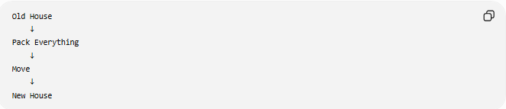
You transfer your belongings while continuing your daily life.
Software migration works the same way:
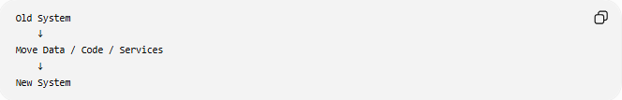
Old System
↓
Move Data / Code / Services
↓
New System
while trying to keep everything working correctly.

🧭 Summary
# Source: AI Source: Provided by: [Data Path: Persons Table -> ID Column: 1, Name_En Column: Motasem Essam] -> From: [ChatGPT] on [6/7/2026]
Migration in software is the process of moving, upgrading, or transforming software systems, data, applications, databases, servers, APIs, or infrastructure from one environment or technology to another. It is performed to modernize systems, improve performance, enhance security, reduce costs, and support future growth while minimizing disruption and preserving functionality.

